Name _________________________________________________
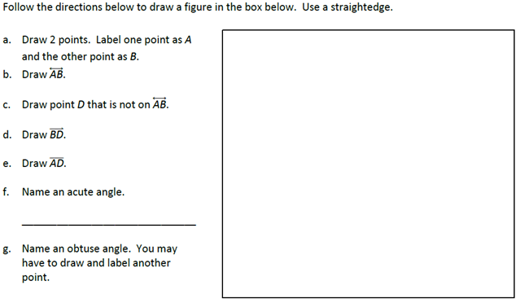

Name ___________________________________________________

