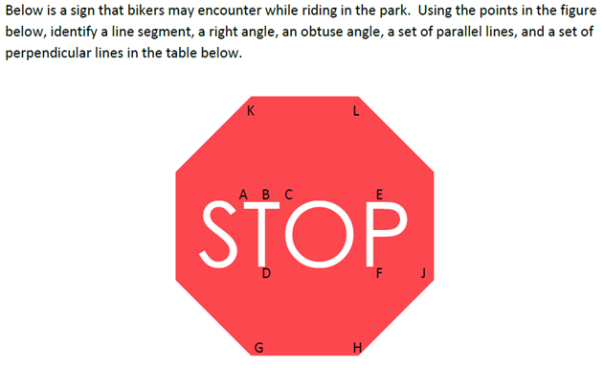Name _________________________________________

Line Segment
Right angle
Obtuse angle
Parallel
Perpendicular

Name ______________________________________________

Line Segment
Right angle
Obtuse angle
Parallel
Perpendicular

