I can understand that shapes in different categories may share attributes.

Place an X in the box to classify the shape using the shape’s attributes.
Each shape may have more than one X.
 | 12. Irregular | 13. Regular | 14. Quadrilateral | 15. Parallelogram | 16.  Square | 17. Rectangle | 18.  Rhombus
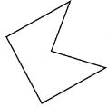
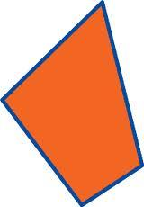

19. The shapes from questions above, all have different attributes. Using your knowledge of geometry, explain the attribute (or attributes) all of these shapes share.

20. What would this classification be called?

